**Performing A Simple Windows PowerShell Script**

A Simple Task to count number

1. Line
2. Words
3. Character
4. Size

Step 1- Writing Script

Open a Normal Notepad and give it extension “*.ps1”.

Write the following Code.

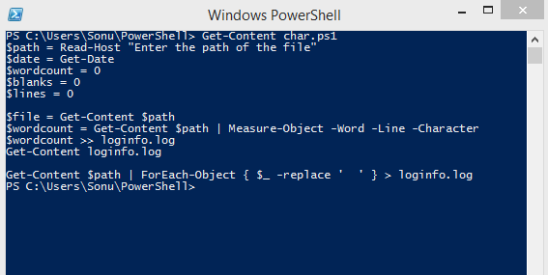

Step-2: Executing Script

To execute a script: .\ScriptName.ps1, if it’s in Current Directory.

